Binary arithmetic
- Addition
- Subtraction
- Multiplication
- Division
See also: https://ryanstutorials.net/binary-tutorial/binary-arithmetic.php
Addition
Adding unsigned numbers
Adding unsigned numbers in binary is quite easy. Recall that with 4 bit numbers we can represent numbers from 0 to 15. Addition is done exactly like adding decimal numbers, except that you have only two digits (0 and 1). The only number facts to remember are that
0+0 = 0, with no carry,
1+0 = 1, with no carry,
0+1 = 1, with no carry,
1+1 = 0, and you carry a 1.
so to add the numbers 06₁₀=0110₂ and 07₁₀=0111₂ (answer=13₁₀=1101₂) we can write out the calculation (the results of any carry is shown along the top row, in italics).
Decimal | Unsigned Binary
1 (carry)  06  +07  13 | 110 (carry)  0110  +0111  1101
Subtraction

Binary Subtraction
Subtraction and Borrow, these two words will be used very frequently for the binary subtraction. There are four rules of binary subtraction.
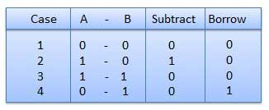

Example − Subtraction
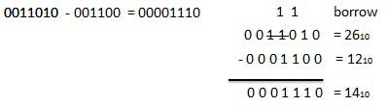
Multiplication
Multiplying unsigned numbers
Multiplying unsigned numbers in binary is quite easy. Recall that with 4 bit numbers we can represent numbers from 0 to 15. Multiplication can be performed done exactly as with decimal numbers, except that you have only two digits (0 and 1). The only number facts to remember are that 0*1=0, and 1*1=1 (this is the same as a logical "and").
Multiplication is different than addition in that multiplication of an n bit number by an m bit number results in an n+m bit number. Let's take a look at an example where n=m=4 and the result is 8 bits
Decimal | Binary
10  x6  60 | 1010  x0110  0000  1010  1010  +0000  0111100

Binary Division
Binary division is similar to decimal division. It is called as the long division procedure.

Example − Division
